ARTICLE TITLE, WHICH ADEQUATELY DESCRIBES THE CONTENT OF THE MANUSCRIPT
Firstname Lastname ¹, Firstname Lastname ², Firstname Lastname ^{2,}*

Affiliation 1 (example: University of Ljubljana, Faculty of Health Sciences, Department of Nursing, Ljubljana, Slovenia)
Affiliation 2

* Corresponding author:
E-mail: ...
Tel.: ...
Address: ...
ARTICLE TITLE IN ENGLISH
Abstract Text in one paragraph (up to 200 words)
Keywords: (up to 8, separate with a comma)
NASLOV ČLANKA V SLOVENSKEM JEZIKU
Izvleček Besedilo izvlečka v enem odstavku v slovenskem jeziku (do 200 besed)
Ključne besede: (največ 8, ločene z vejico)
1 INTRODUCTION
The introduction should briefly place the study in a broad context and highlight why it is important. It should define the purpose of the work and its significance. The current state of the research field should be carefully reviewed, and key publications cited. Please highlight controversial and diverging hypotheses when necessary. Finally, briefly mention the main aim of the work and highlight the principal conclusions. As far as possible, please keep the introduction comprehensible to scientists outside your field of research.
2 MATERIALS AND METHODS
2.2 Subheading
The Materials and Methods should be described with sufficient details to allow others to replicate and build on the published results. Please note that the publication of your manuscript implicates that you must make all materials, data, computer code, and protocols associated with the publication available to readers. New methods and protocols should be described in detail while well-established methods can be briefly described and appropriately cited.
- RESULTS
3.3 Subheading
This section may be divided by subheadings. It should provide a concise and precise description of the experimental results, their interpretation, as well as the experimental conclusions that can be drawn.

Example of a figure illustrating the results: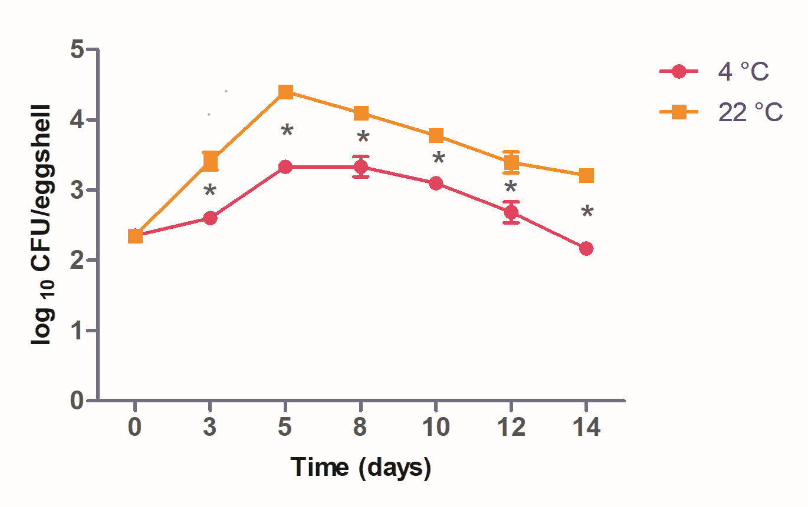
Figure 1. Caption describing the content of the figure. Figures should be placed in the main text immediately after the paragraph in which they are first mentioned.
Example of a table summarizing the data:
Table 1. Caption describing the content of the table. Tables should be placed in the main text near their first citation. Long or excessive tables should be avoided.
Header | Header | Header
Text | Text | Text
Text | Text | Text
Text | Text | Text
Text | Text | Text

- DISCUSSION
Authors should discuss the results and how they can be interpreted from the perspective of previous studies and of the working hypotheses. The findings and their implications should be discussed in the broadest context possible. Future research directions may also be highlighted.

5 CONCLUSIONS
This section is not mandatory but can be added to the manuscript if the discussion is unusually long or complex.

Author Contributions
For papers with multiple authors, briefly describe each author’s contribution using standard roles (e.g., conceptualization, methodology, writing, supervision). Follow the CRediT taxonomy for role definitions. Include a final statement: “All authors have read and agreed to the published version of the manuscript.” Authorship should include only those who made a substantial contribution.

Acknowledgement
Please acknowledge any support given which is not covered by the author contribution or funding sections.

Funding
Please state either: “This research received no external funding” or “This research was funded by [funder name], grant number [XXX].”
If applicable, you may also add: “The project was funded by [XXX].”

Data Availability
Please specify how the data supporting this study are available. Data may be publicly available in a repository (please provide the link), available on request from the authors, or not available (with justification).
Data should follow the FAIR principles (Findable, Accessible, Interoperable, Reusable).

Conflicts of Interest
Please declare any conflicts of interest or state: “The authors declare no conflict of interest.”
If applicable, also indicate the role of the funders in the study.
6 REFERENCES
Apply the APA system.

